21st Century Lesson
Grade 9 ELA
L2: How are dynamic characters created?

Overview

Lesson Goal | Create an animated sequence to introduce a character.
Outcomes | 2.1 participate in a positive way in different types of discussion  8.3 choose words carefully for a desired effect  10.3 experiment with technology to communicate
Driving Question | How are dynamic characters created?
Materials | Overhead projector and online computer  Individual online devices  App Link (Android): Heads Up! OR App Link (Android): Charades  Slideshow: Character Clips  Video: What A Character!  Video: What A Character! Analysis  Video: UP 1  Video: UP 2  Possible Animation Apps/Websites:  App Link (Apple): Toontastic  Powtoon  Flipbook  ZimmerTwins  Tellagami  Blabberize  Peer Evaluation: What A Character!
21 Century Competencies | Entry I II III IV  Find and Validate ✔ ✔  Communicate and Collaborate ✔ ✔ ✔  Analyse and Synthesize ✔ ✔  Apply and Connect ✔ ✔ ✔  Evaluate and Leverage ✔ ✔  Create and Publish ✔ ✔
Estimated Time | 180 minutes
Lesson:

Entry Event  Play a game of Heads Up! Or Charades (Characters/People only)  Player puts device on forehead and group members need to act out role of person/character, so that player can guess who’s name is on the device.  Debrief how you were able to determine who the person/character was.  Example: What they said, how they talk, body language etc.  Discuss:  Who are your favourite characters? Why do you like them? |  | Resources:  Individual online devices  App Link (Android): Heads Up!  App Link (Android): Charades

I. Introduction (Teacher organized)  Why is character so different from a child’s story to a powerful author’s description?  - As our understanding of human nature grows, we can create more three dimensional, dynamic characters.  - Vocabulary proficiency allows greater nuance.  - Use a variety of methods to reveal character.  Introduction to the ways authors reveal character in story.  Students are to record the ways authors reveal character. |  | Resources:  Overhead projector and online computer  Slideshow: Character Clips  Video: What A Character!  Video: What A Character! Analysis

II. Guided Learning (Teacher/student collaboration)  Watch the video clips from the movie UP.  Record and discuss each character’s traits, evidence from the clips, and method of characterization, completing the chart together as a class.  Description How do I know? Method  Carl  Ellie  Discuss: Are Carl and Ellie dynamic characters? Why do you think that?  Students work with a partner to select their own short Youtube clip which reveals a character’s traits in some way.  Share a selection of videos, having students explain what they learned about the character and how the author/creator revealed their traits.  Teacher points out any subtleties students may have missed.  Maintain discussion focus on what makes a dynamic character. | Resources:  Video: UP 1  Video: UP 2  Individual online devices

III. Collaborative Learning (Student focused activity)  Students work together in partners to create their own animated sequence which reveals a character.  Students are encouraged to use as many of the ways authors reveal character as feasible, and to create dynamic, deep characters. | Resources:  Individual online devices  App Link (Apple): Toontastic  Powtoon  Flipbook  ZimmerTwins  Tellagami  Blabberize

IV. Grande Finale  Animations are shared with the class in a round robin set-up  (leave devices with animations running/available at a station and move around the room to view others’ work.) | Resources:  Individual online devices

Reflection/Feedback/Assessment  As students are engaged in round robin viewing, they will leave feedback at each station. | Resources:  Peer Evaluation: What A Character!

Differentiation  Selective partnering for animation task.  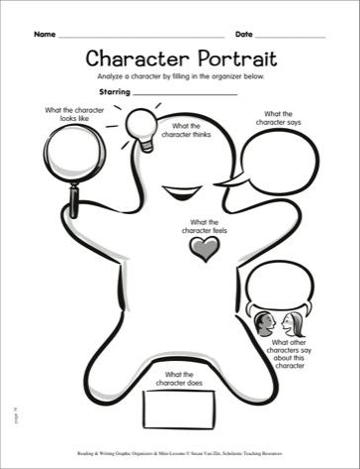  Use of graphic organizer for UP character traits. | Resources:

