21st Century Lesson
Grade 9 - ELA
L6: Watch Your Language!

Overview

Lesson Goal | Develop fluency in the use of figurative language.
Outcomes | 8.3 choose words carefully for a desired effect
Driving Question | Why do writers use figurative language?
Materials | Overhead projector and online computer  Individual online devices  Lyrics: Firework  Audio: Firework  Video: Figurative Language  Review: Kahoot
21 Century Competencies | Entry I II III IV  Find and Validate ✔ ✔  Communicate and Collaborate ✔ ✔  Analyse and Synthesize ✔  Apply and Connect ✔ ✔ ✔  Evaluate and Leverage ✔  Create and Publish ✔ ✔
Estimated Time | 60 minutes

Lesson:

Entry Event  Hand out copies of the lyrics of the song.  While listening, have students circle the words or phrases that create the most powerful images or feelings. |  | Resources:  Lyrics: Firework  Audio: Firework

I. Introduction (Teacher organized)  Introduce types of figurative language.  Obviously, there are many more, but this lesson focuses on six: simile, metaphor, hyperbole, personification, imagery, and onomatopoeia.  Students need to record definitions from the video. |  | Resources:  Overhead projector and online computer  Video: Figurative Language

II. Guided Learning (Teacher/student collaboration)  Part 1  Students play Kahoot as a review of terms.  Note:  Teacher must prepare Kahoot ahead of time. There are many websites with easy examples of the 6 types of figurative language to use for the Kahoot quiz.  Part 2  Once comfortable identifying examples of figurative language, return to lyrics.  Students are to colour code the figurative language used in the song. For example:  Purple - onomatopoeia  Yellow - simile  Grey - hyperbole  Blue - metaphor  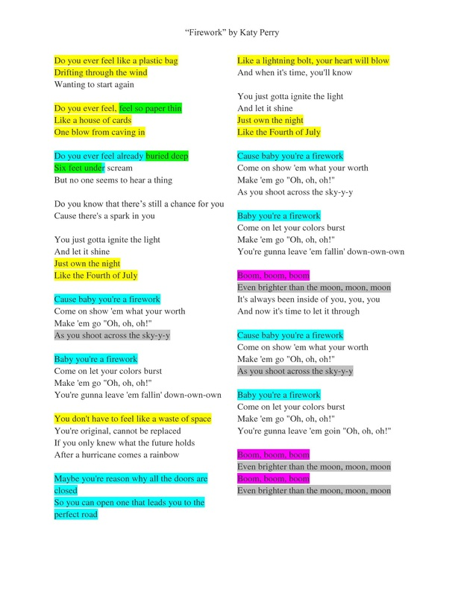  Discuss:  Was there a correlation between the powerful images/feelings and the type of language used? Why do writers use figurative language? | Resources:  Individual online devices  Review: Kahoot

III. Collaborative Learning (Student focused activity)  With a partner, students will construct a conversation that is entirely made up of figurative language.  Conversation can be about any (school appropriate) topic. | Resources:

IV. Grande Finale  Students may choose to either present their conversation to the class or submit a written copy. | Resources:

Reflection/Feedback/Assessment  Feedback from Kahoot will indicate students who are possibly having difficulty.  Conversation will be graded for mastery of use of figurative language. | Resources:

Differentiation  Option to draw examples of each of the six types of figurative language.  Provision of notes/definitions.  Narrow search for particular types of figurative language in lyrics. EX: only similes. | Resources:

